***Knowledge discovery and management***

***Report on Project Increment-4***

**By:** Bathina, L V Sandeep  
Shah, Vidhi Jagdishchandra  
Rama krishna Tammabathula

The Goal of this project is to develop a Disease Management system to give users the information either the demographics or the statistics of the diseases along with the hospital and doctor information available in the area. Thus giving a chance for the better analysis and reducing in the health care expenditure.

**Architecture Diagram:**



Following the above approach, we stored our data in Hadoop and we have used Solr for full text searching. Output of Solr search is displayed on application which user operates.

**Activity Diagram:**

First, user will enter a disease name in a text box and click “Disease Information” button. As soon as user will hit this button, information regarding to that disease and disease symptoms will display. On that page only, user can input Disease type like orthopaedic, cardiologist, etc and the specialist for a given disease type will be displayed on another page.

**Disease Specialist Doctor**

On load event of Page

Disease Type

**User INPUT:**

Disease Information

Disease Symptoms

**User OUTPUT:**

 On click event of button

**Disease name**

**User INPUT in TEXT BOX:**

After this, when user click “Best Nearby Hospital” button , user will get the list of Hospital of that area along with location indicator map of listed hospitals which will show way of reaching respective hospital from user’s location.

Here, we have considered two different cases:

* Emergency
* Non-emergency

Below diagram shows, the case emergency in which when user select the “emergency” radio button and then select the “best nearby hospital” , two nearer hospitals will display with map which shows hospital location from user’s location.

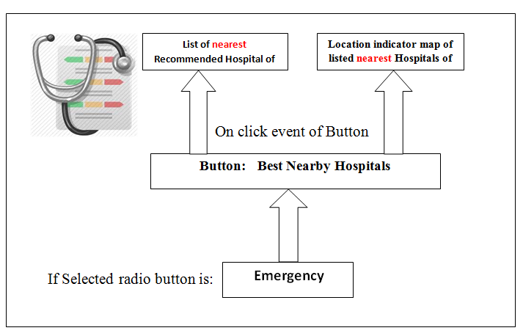

In case of non-emergency, when user select the non-emergency radio button and select “best nearby Hospitals” then best three hospitals address with map will display which will show the location of hospital from user’s location.

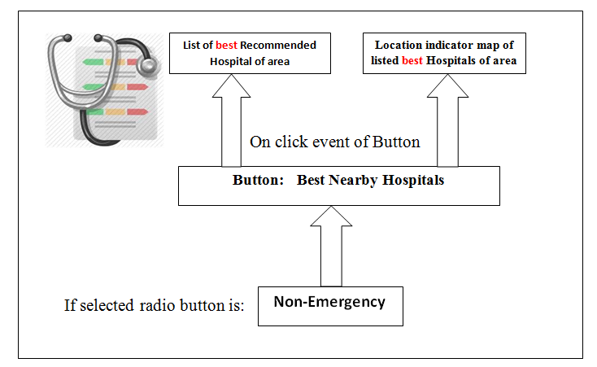

**Class Diagram:**

|  |
| --- |
| **MainPage-2** |
| -ctask |
| #OnNavigatedTo()  -Google API  - ReommendedHospitalButton_Click() |

1

|  |
| --- |
| **RegisterPage** |
|  |
| -ProcessRegisterRequest  (in responseStream)  -FailRegisterRequest(in message : string)  -RegisterButton_Click() |

|  |
| --- |
| **LoginPage** |
|  |
| #onNevigatedto()  -ProcessLoginRequest(in  response stream)  -FailLoginRequest(in message : string)  -LoginButton_click() |

1

|  |
| --- |
| **MainPage-1** |
| -ctask |
| #OnNevigatedTo()  -SearchButton_Click() |

**Implementation:**

Following the architecture diagram, first we pushed our data into hadoop and from hadoop we pushed that in solr.

**Steps we followed:**

* Implemented Restful web service to push the JSON file to the SOLR

**Screenshot: 1** coding that we did for pushing JSON file to Solr

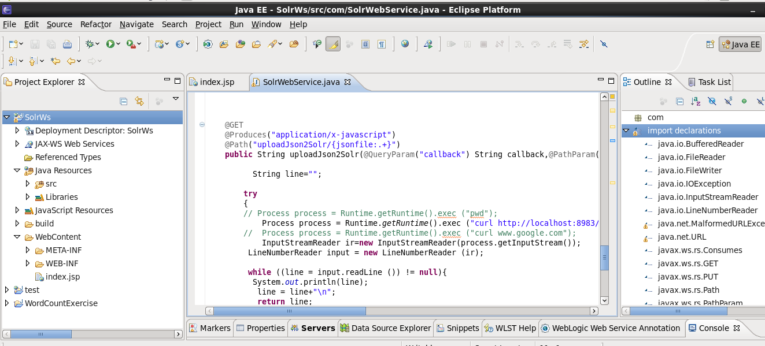

* exported the web service to war file and deploy this service on to the Glassfish server

**Screenshot: 2** deployment of service on to GLASSFISH server

c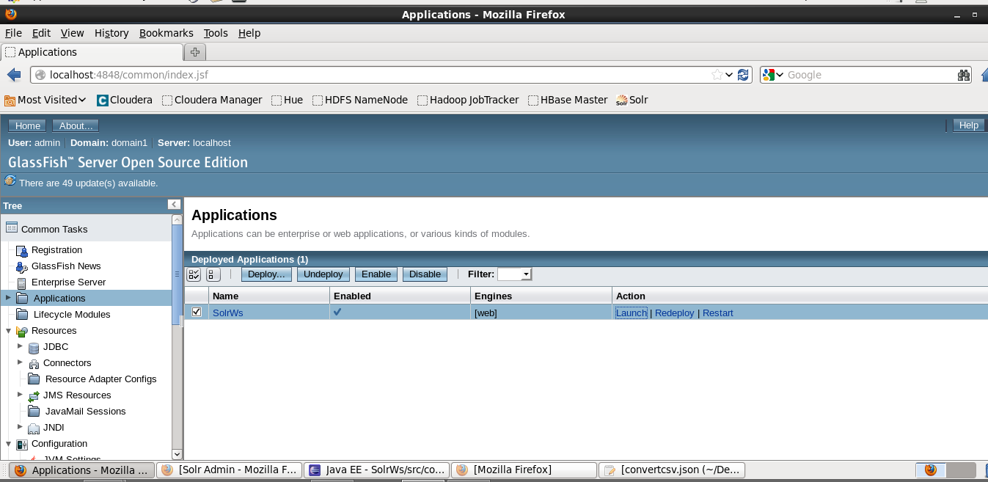

* Converted the text file of disease information to the JSON format

**Screenshot: 3** text file conversion in JSON format

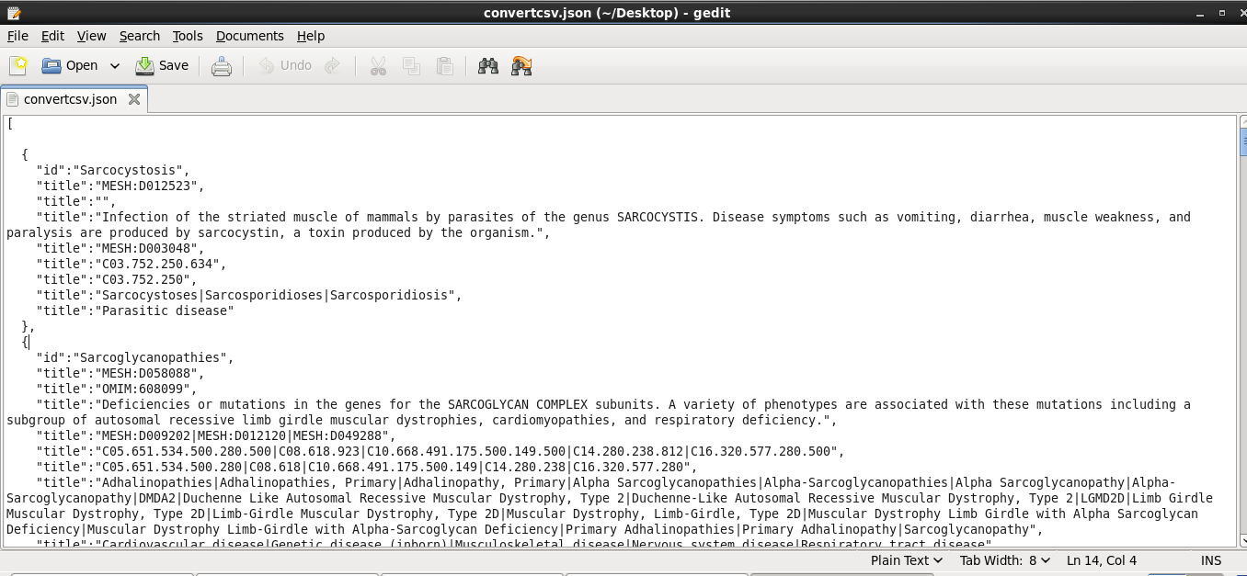

* executed the service by http://localhost:8080/SolrWs/jaxrs/generic/uploadJson2Solr//<Json file path>

**Screenshot: 4** execution of service

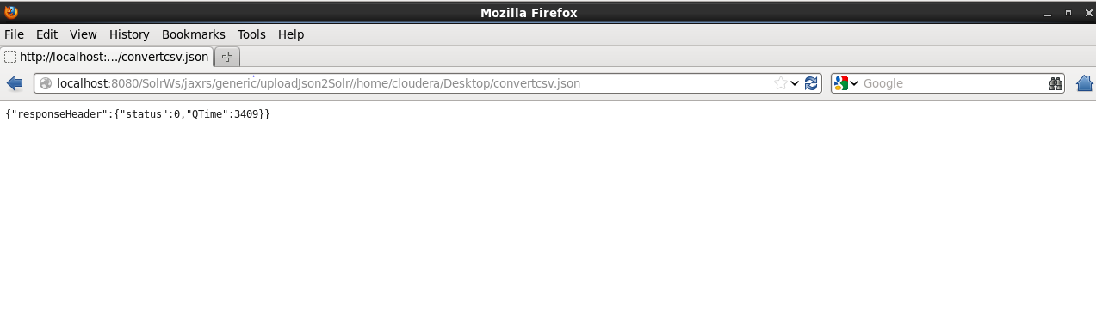

* Here a total of 11824 disease information got stored in the solr as below.

**Screenshot: 5**  data in solr

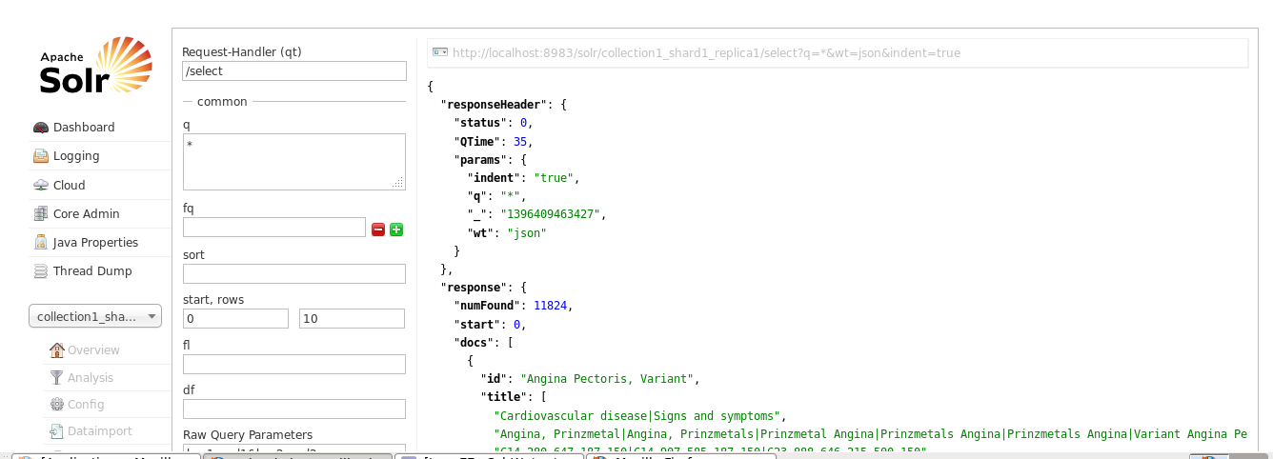

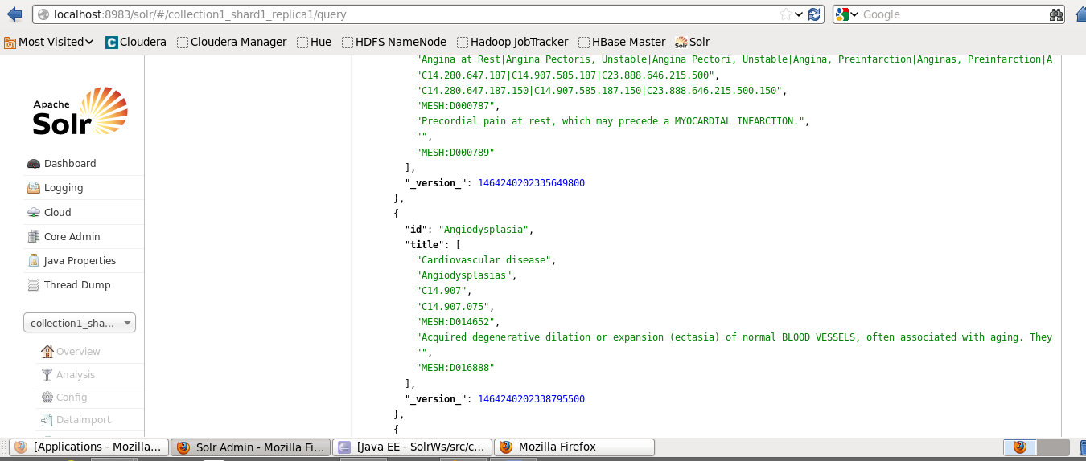

**User interface:**

Screenshot of the registration page for the user:

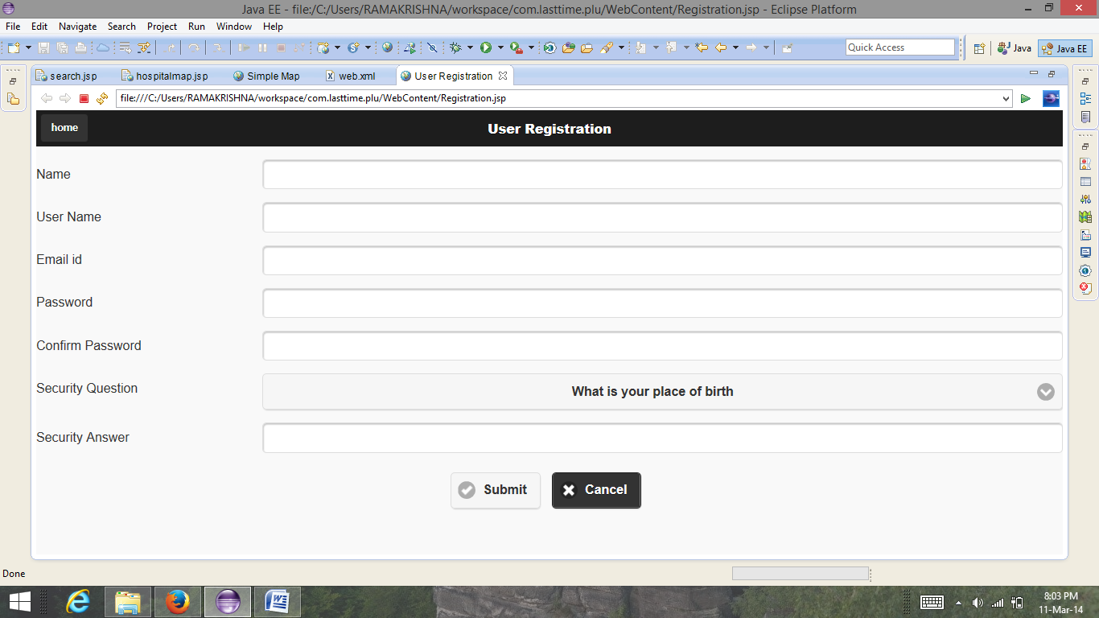

Screenshot of Sign in page:

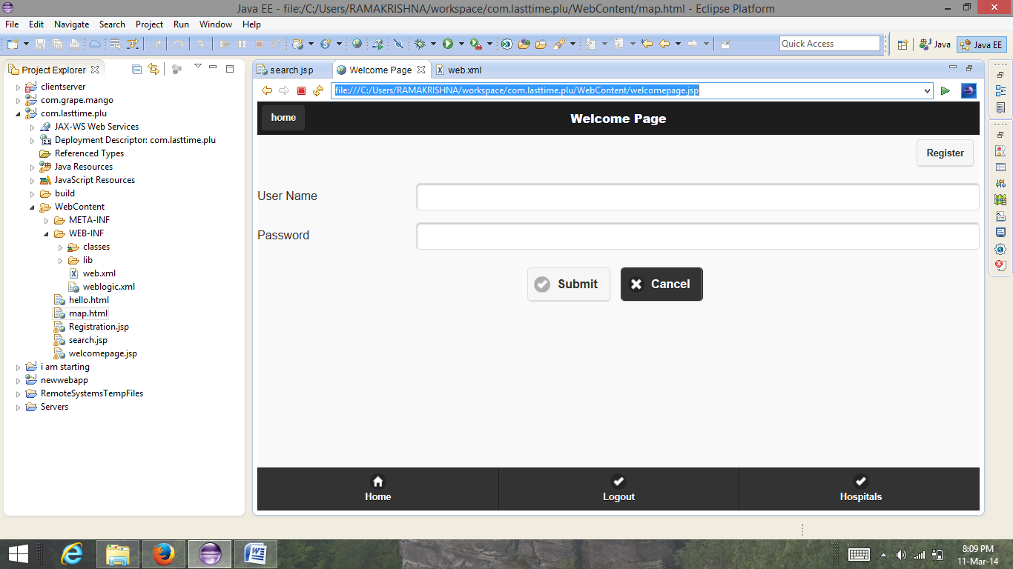

This is the main page of the application and It returns the results that are obtained using the solr and it also has the link to the map containing hospitals list.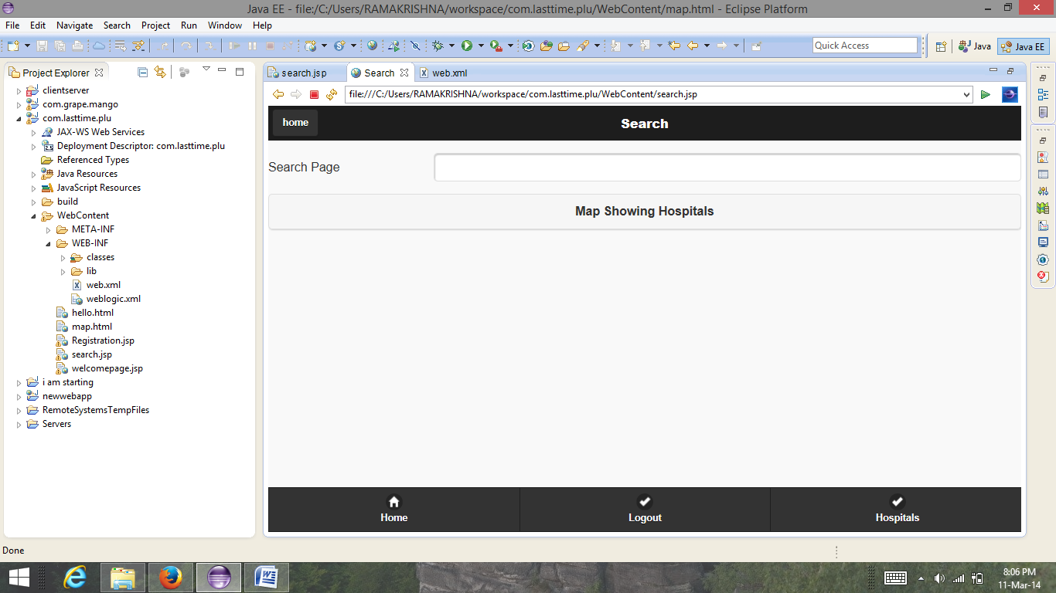

The map showing the hospitals in the given location. We made this map as our project is location based.

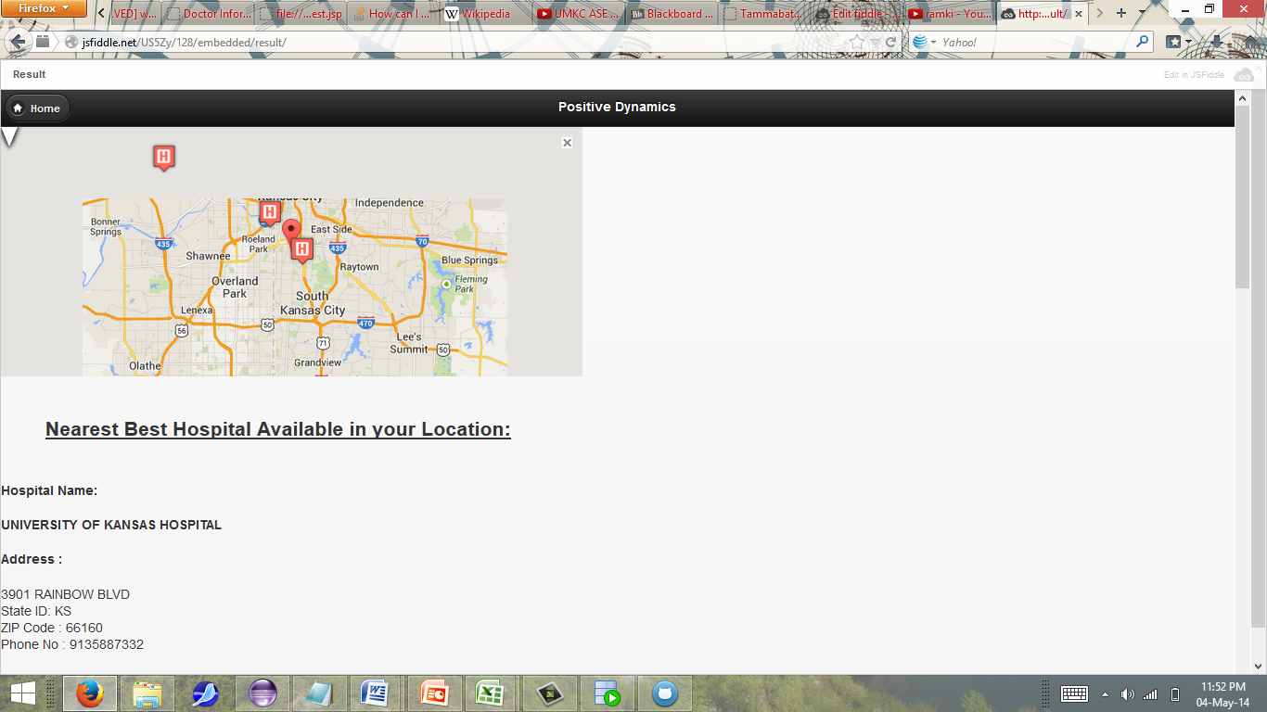

Screenshots of lucene indexing:

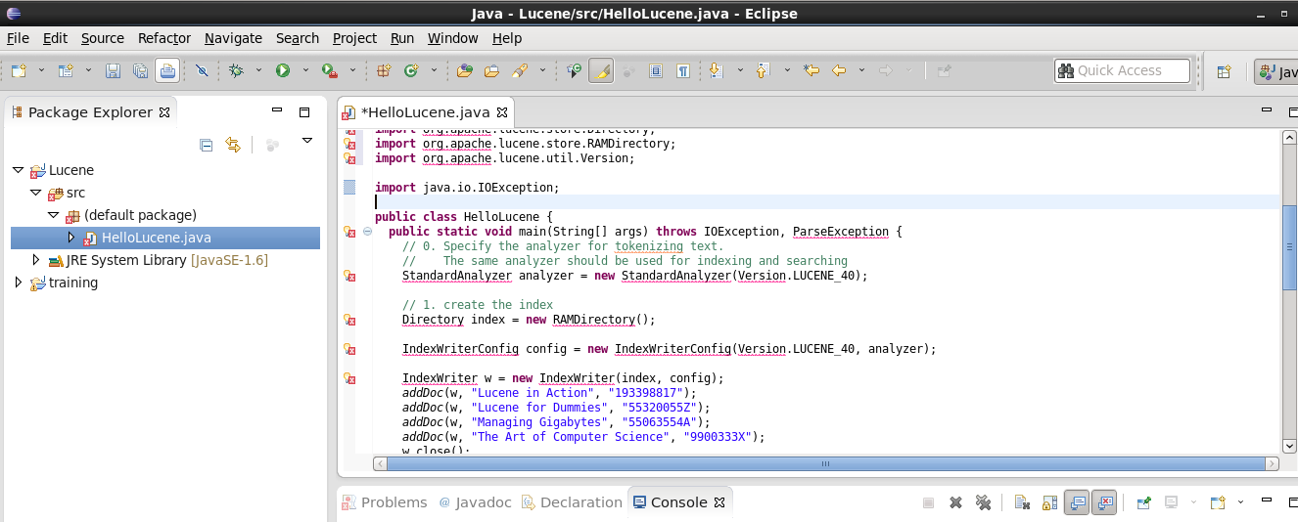

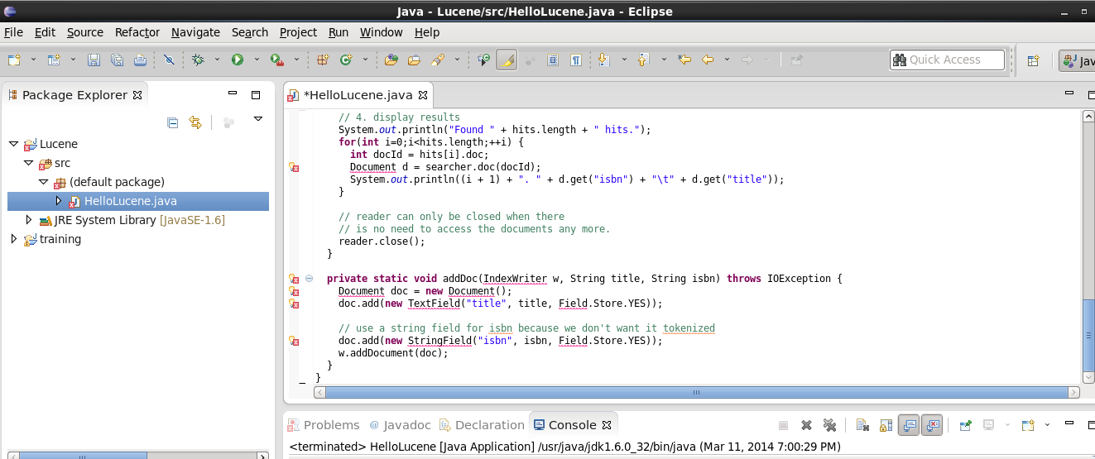

Error:

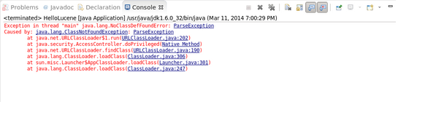

Solr:

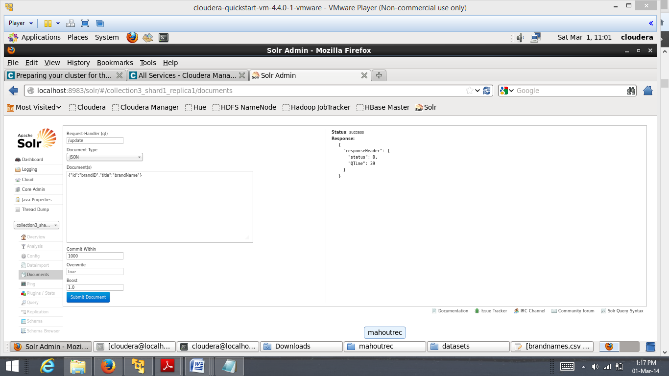

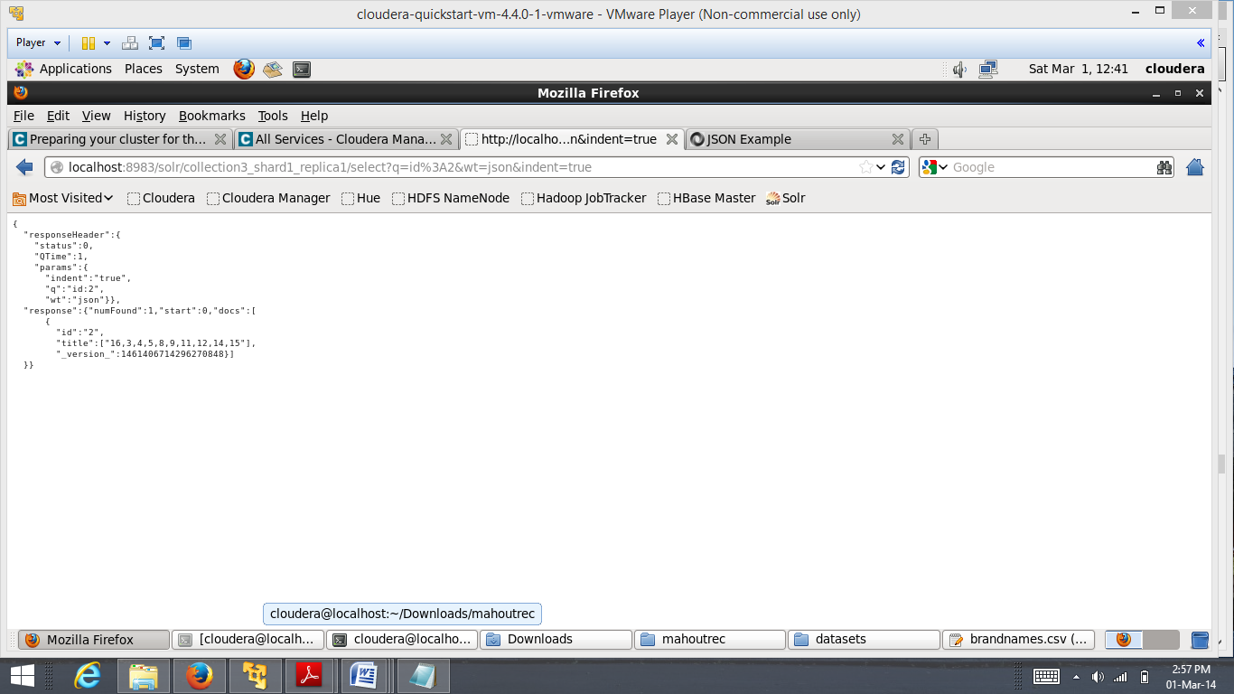

**Domain Model:**

1. **Data sources:**

* <https://data.medicare.gov/Physician-Compare/National-Downloadable-File-Extended-View/3uxj-hea6>
* <https://data.medicare.gov/data/medicare-s-helpful-contacts>
* <https://data.medicare.gov/data/home-health-compare>

1. **Algorithm:** We have used recommendation algorithm. Here, the best hospitals are recommended for particular place.

**Application Specification:**

1. **Web services** **:** RESTful API
2. **Programming languages :** JAVA
3. **Front end:**   JQuery Mobile, HTML 5,Android
4. **Hadoop distribution :** Cloudera
5. **Machine Learning tool :** Mahout
6. **Searching tool :** solr

**Design of mobile client:** we have used “JQuery” for front end.

**Implementation:** We made mobile application and stored data in hadoop and using solr for full text search mechanism which is interfaced with mobile application.

**Technologies:**

Jersey framework(Rest services)  
Solr   
R(Machine Learning)  
Spring Framework  
Mongo DB

**Project management:**

Team Involvement:

1. Rama Krishna :User Interface and Solr search and retrieval and machine learning in r
2. Sandeep : Maps and solr search and solr retrieval
3. Vidhishah : User Interface